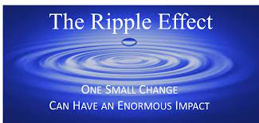
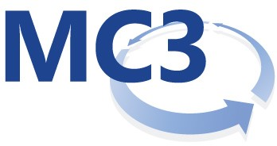

2024 Theme: The Ripple Effect:
As agents of change, we must create an atmosphere that feels welcoming and hopeful. One small act of positivity can have a huge impact on the world around us. Acts of kindness are Contagious. Have you ever noticed that when someone does something nice for you, you are more likely to do something nice for someone else? This is the ripple effect in action. Creating a ripple effect can break down barriers, create a safer Society, inspire positive change and create impactful waves for the behavioral health consumers we serve here in Milwaukee County.
January 24th-Positive Mindset, Positive Year: Presented by Don Sandel- Times are tough and there few professions feeling it as much as those in the critical field of behavioral health. As the new year commences, such important but embattled professionals could use a reminder how important our mindset is to our outcomes. What a great way to begin the year! In this virtual presentation, you will be reminded that we are better in every domain of our lives with a positive mindset. According to the research, we are better parents, partners and professionals. In fact, this is more than just a social virtue or a nice thing to do, our physiology actually changes, enabling our best to emerge as we strive to help others. You will learn about the research and neuroscience that supports these claims, new ways to sustain a positive mindset, and leave feeling more happy and more optimistic about the future.

February 28th -Achieving Individual, Organizational And Team Health To Promote Co-Occurring Disorders Recovery Presented by Mark sanders
March 27th- NO Change Agent Meeting – Spring Break!

April 24th Title: Caring for Yourself as you Care for Others: The Ripple Effect of Sustaining Staff Wellbeing as a Pathway to Quality Improvement Presented by Leslie Anne Ross, Psy.D.

Presentation Description: The relationship between provider wellbeing and quality of care for patients and clients is well documented in the literature. However, the pathway to sustained wellness in a stressful trauma exposed workplace is often unclear. In this presentation, we will learn three ways to increase provider wellness; 1) self-assessment, 2) promoting protective factors in the workplace and 3) Practicing Self-Regulation and Resilience Building Skills.
In this interactive, reflective training, participants will have the opportunity to learn about the impact of secondary traumatic stress (STS) and provider distress on staff and the quality of care that they are able to provide. Individual and organizational strategies to reduce the risk of STS will be discussed as well as an opportunity to develop a wellness plan for success.

May 22nd - IN PERSON MEETING! - Presented by Kelly Bubolz
Building Resiliency Workshop
Workshop Description: Build resilience and navigate through change with ease. You'll leave with an action plan to begin moving forward in this chaotic, fast-paced world. Learn the four behavioral changes contributing to burnout, how to respond, and move back to energy as an individual and driver of change to keep the ripple effect alive! This workshop is a flow of exploring self-awareness brain tendencies, small group discussion and breaking down your action plan.
Objectives: Participants will learn the brain tendencies causing added stress and the four behavioral categories of stress management. Participants will explore energy and burnout contributors 100% in their control to create a practical action plan on an individual and also team level.

July 24th- IN PERSON MEETING! Why is our Village Burning?- Presented by A.S.K. (Access Support and Knowledge), A.S.K is a community outreach platform by Brenda Wesley to educate the community by people from the community.
This presentation will cover generational trauma experienced by the African American community. Presentation objective is to "Make a Connection" with past and present African American struggles and traumatic experiences known today. This was taken from the concept of "It takes a village” and will look at the ripple effect of generational trauma specific to the Black community.
August 28th- MC3 Orientation

September (dates not decided just yet) – More Details to come!
October 23rd- IN PERSON MEETIING! Niatx Storyboard Market Place
November 27th- No change agent meeting

